FIRE INVESTIGATION
Which of the following findings from a fire scene suggests that the fire was arson?
- Puddle-shaped burn pattern
- Foreign ignitable liquids in burned material
- Crazed window glass
- V-shaped burn pattern
After a fire, the molten wires in electrical cords often assume the shape of beads. If the demarcation (border) of such a bead is not sharp, it suggests that __________ has caused the fire.
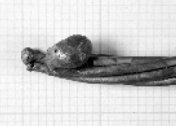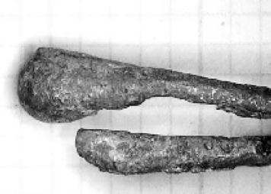
Copper bead with a sharp demarcation. Copper bead with a demarcation that is not sharp
- burning from the outside
- an electric spark
- an ignitable liquid
- human negligence
After a fire, window glass often shows a complicated pattern of short cracks, which is called crazing. What causes crazing?
- Air pressure from the outside.
- Air pressure from the inside.
- Rapid heating of cool glass.
- Rapid cooling of hot glass.
What technique would a forensic scientist use to confirm if an ignitable liquid was used to start a fire?
- Spectrophotometry
- Gel electrophoresis
- Gas chromatography
- Electron microscopy
TOXICOLOGY
To confirm if somebody died from smoke inhalation during a fire, the amount of __________ in the blood is determined.
- soot
- clotted erythrocytes
- deoxyhemoglobin
- carboxyhemoglobin
Spectrophotometry is a method that is based on the ability of molecules to __________ light.
- absorb
- emit
- polarize
- refract
You are setting up a headspace gas chromatography analysis to determine the amount of ethanol in a sample. What would you choose as a positive control?
- Diluting buffer
- Water
- A different alcohol, such as isopropanol
- Ethanol
Look at the gas chromatogram below. What do the different peaks represent?
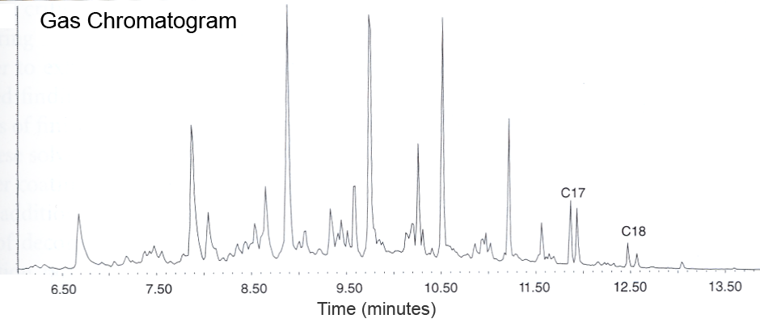
- Fragments of one and the same chemical.
- Different chemicals in the sample
- Isotopes of one and the same chemical
- Different amounts of one and the same chemical.
A suspect has been found to have amphetamines in his blood. What technique can be used to find out which specific amphetamine it is?
- Enzyme-Linked ImmunoSorbent Assay (ELISA)
- Headspace gas chromatography
- Gas chromatography/Mass spectrometry
- Spectrophotometry

